How to order your textbooks online



**2.**

**1.**

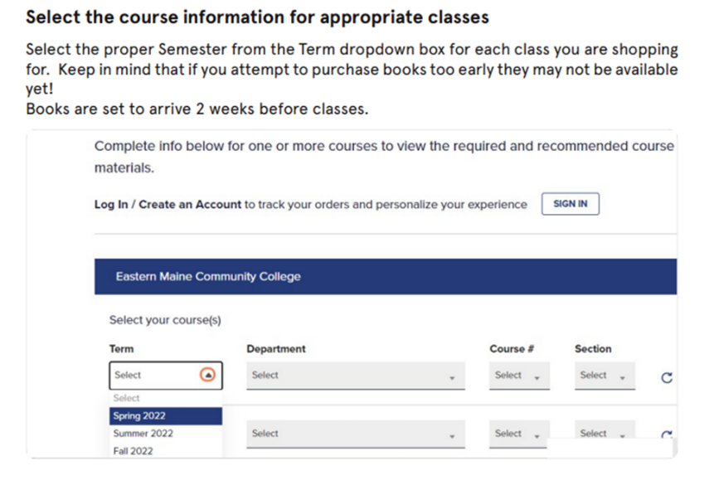

5.

4.

3.

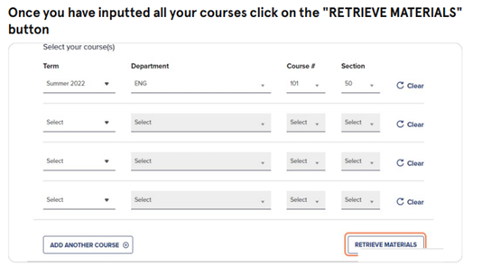

6.

7.

8.

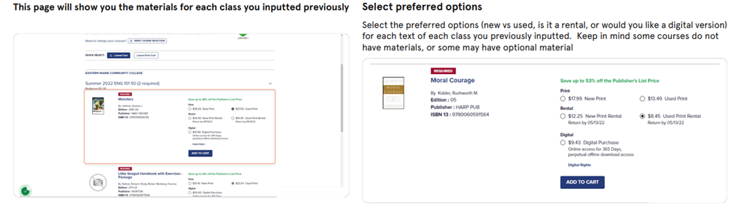

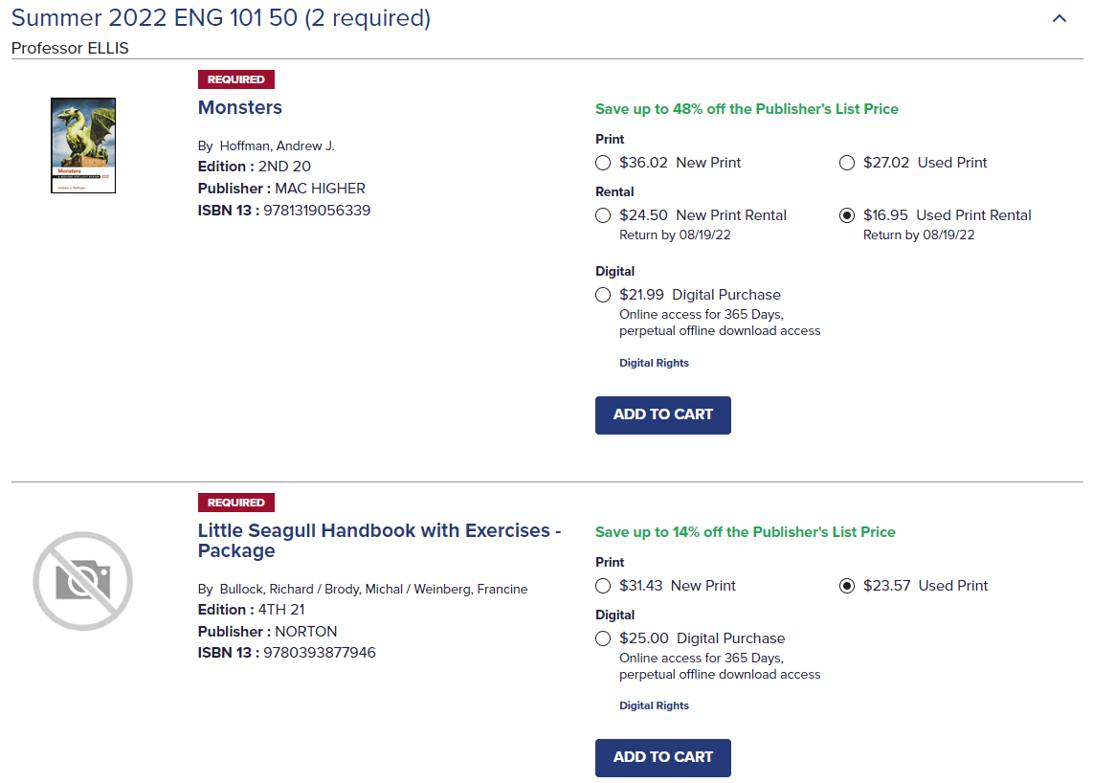

9.

10.

11.

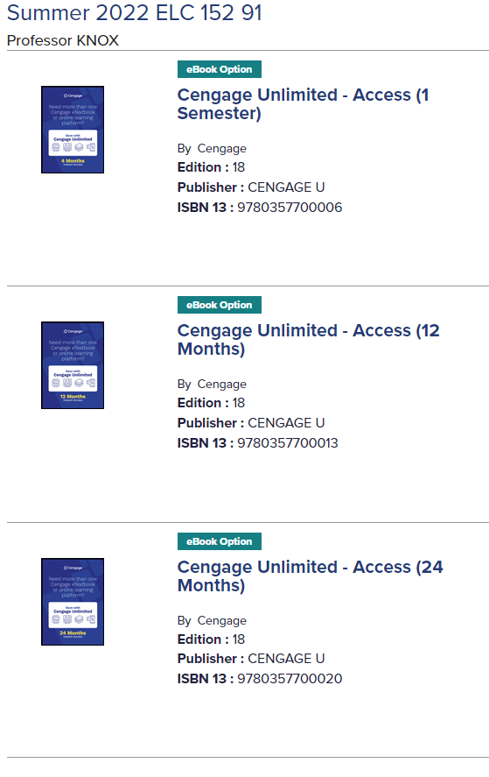

12.

13.

21.

20.

19.

18.

17.

16.

15.

14.